9.60-8th Main question

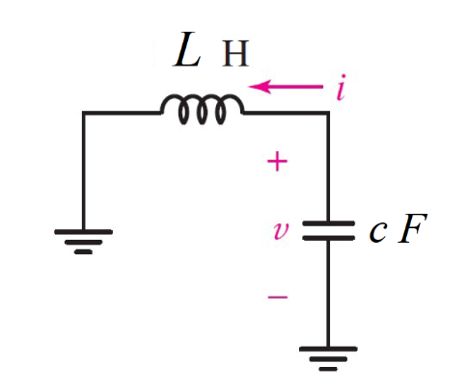

Given v(0)=0 V, i(0) = 1 mA, c = 2 *n*F, l= 10 pH

Find

Variables

Random variables

#l < 4*r*r*c Parallel, c < 4*r*r/l Series

c = {1e-9:5e-9:1e-9};

l = {10e-12:12e-12;1e-12};

Global variables

#v0 = 0 ;i0 = 1e-3; c = 2e-9;

l = 10e-12; time = 0.001;

# t = ∞

vf=0;

# t = 0+

alpha = 0;

w0 = 1/sqrt(l*c);

wd = sqrt(w0*w0-alpha*alpha);

ic=is0p-il0;

A1 = vc0;

A2 = (ic0/c+alpha*A1)/wd;

vt = vf+(A1*cos(wd*time) + A2*sin(wd*time))exp(-alpha*time);

Part (กรอกคำตอบ)

1. *α* = alpha = 0 s^-1
2. *ω*0 = w0 = 7.07x 109 rad/s

At *t* > 0

1. *v*(*t*) = vf+(A1*cos(wd*t) + A2*sin(wd*t))exp(-alpha*t)

= -7.0711x10-5*sin(7.07x109*t) V

1. *v*(time*τ*) = vt = -2.2837x10-5V

9.61-8th Main question find it

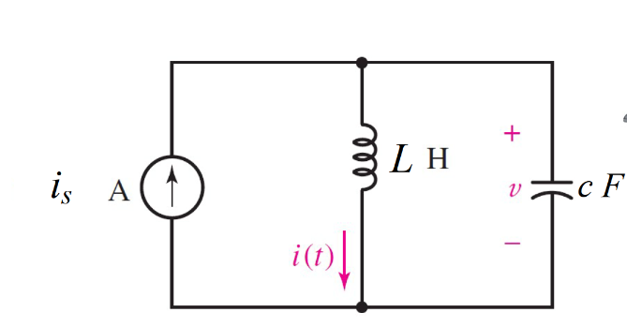

Given is = 2 *u(-t)* A, c = 1 *m*F, l= 20 H

Find it

Variables

Random variables

#l < 4*r*r*c Parallel, c < 4*r*r/l Series

is = {1:5};

c = {1e-3:5e-3:1e-3};

l = {10:20};

Global variables

#is0n = 2; is0p=0 ; c = 1e-3;

l = 20; time = 1;

# t = 0-

i0=is0n;

v0=0;

# t = ∞

vf=0;

if=is0p;

# t = 0+

alpha = 0;

w0 = 1/sqrt(l*c);

wd = sqrt(w0*w0-alpha*alpha);

A1 = i0;

vl0=v0;

A2 = (vl0/l+alpha*A1)/wd;

it = if+(A1*cos(wd*time) + A2*sin(wd*time))exp(-alpha*time);

Part (กรอกคำตอบ)

1. *α* = alpha = 0 s^-1
2. *ω*0 = w0 = 7.07 rad/s

At *t* > 0

1. *i*(*t*) = if+(A1*cos(wd*t) + A2*sin(wd*t))exp(-alpha*t)

= 2*cos(7.07*t) V

1. *v*(time*τ*) = it = 1.4122 V

9.61-8th Main question find vt



Given is = 2 *u(-t)* A, c = 1 *m*F, l= 20 H

Find it

Variables

Random variables

#l < 4*r*r*c Parallel, c < 4*r*r/l Series

is = {1:5};

c = {1e-3:5e-3:1e-3};

l = {10:20};

Global variables

#is0n = 2; is0p=0 ; c = 1e-3;

l = 20; time = 1;

# t = 0-

i0=is0n;

v0=0;

# t = ∞

vf=0;

if=is0p;

# t = 0+

alpha = 0;

w0 = 1/sqrt(l*c);

wd = sqrt(w0*w0-alpha*alpha);

A1 = v0;

ic=-i0;

A2 = (ic/c+alpha*A1)/wd;

vt = vf+(A1*cos(wd*time) + A2*sin(wd*time))exp(-alpha*time);

Part (กรอกคำตอบ)

1. *α* = alpha = 0 s^-1
2. *ω*0 = w0 = 7.07 rad/s

At *t* > 0

1. *v*(*t*) = vf+(A1*cos(wd*t) + A2*sin(wd*t))exp(-alpha*t)

= -282.8*sin(7.07*t) V

1. *v*(time*τ*) = vt = -200.253 V

9.62-8th Main question

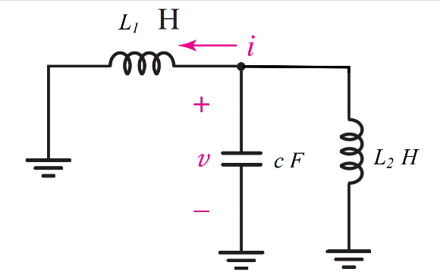

Given v(0)=0 V, i(0) = 1 mA, c = 2 *n*F, l1= 10 pH, l2 = 5µF

Find it

Variables

Random variables

#l < 4*r*r*c Parallel, c < 4*r*r/l Series

c = {1e-9:5e-9:1e-9};

l1 = {10e-12:12e-12;1e-12};

l2 = {1e-6:10e-6;1e-6};

Global variables

# v0 = 0 ;i0 = 1e-3; c = 2e-9; l1 = 10e-12; l2=5e-6; time = 0.002;

# t = ∞

if=0;

# t = 0+

alpha = 0;

leq=(l1*l2)/(l1+l2);

w0 = 1/sqrt(leq*c);

wd = sqrt(w0*w0-alpha*alpha);

A1 = i0;

vl0=v0;

A2 = (vl0/leq+alpha*A1)/wd;

it = if+(A1*cos(wd*time) + A2*sin(wd*time))exp(-alpha*time);

Part (กรอกคำตอบ)

1. *α* = alpha = 0 s^-1
2. *ω*0 = w0 = 1.41x106 rad/s
3. *i*(*t*) = if+(A1*cos(wd*t) + A2*sin(wd*t))exp(-alpha*t)

= 10-3*cos(1.41x108*t) V

1. *v*(time*τ*) = it = -3.45x10-4 V